LIAN LI Launches New Stylish BORA Digital Fans
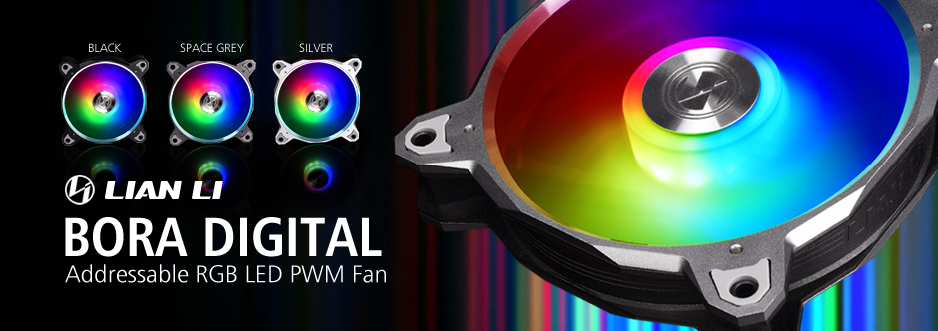

MAY 20th, 2019, Taipei, Taiwan – LIAN LI Industrial Co. Ltd., a world leading manufacturer of aluminum chassis and peripherals, is proud to unveil the latest addition to its family of well-received RGB fan with the BORA Digital. Following the great success of the BORA and BORA Lite cooling fans, the price competitive BORA Digital is here to dominate in style with 3 frame finishes, built-in 12 addressable LEDs customizable via a RGB controller (or motherboard), and one of the most silent performances in the field, thanks to its adjustable speed and fluid dynamic bearings.

A revolutionary style
At last a fan that ticks all the boxes for gamers and enthusiasts alike is here, thanks to LIAN LI and the BORA Digital, an addressable RGB 120mm system fan that stands out, is efficient and stays silent. Available with frames in Silver, Space Grey and Black, the BORA Digital comes ornamented with an elegant LIAN LI logo CNC milled in aluminum at the center of the fan. Surrounding the logo, the built-in 12 addressable LEDs are tactically located to elevate the RGB experience to the next level and let the user truly customize its computer case’s style. At an MSRP of $59.99 USD, the BORA Digital includes a set of 3 fans, a controller, power cables, daisy chaining cables as well as an LED hub.
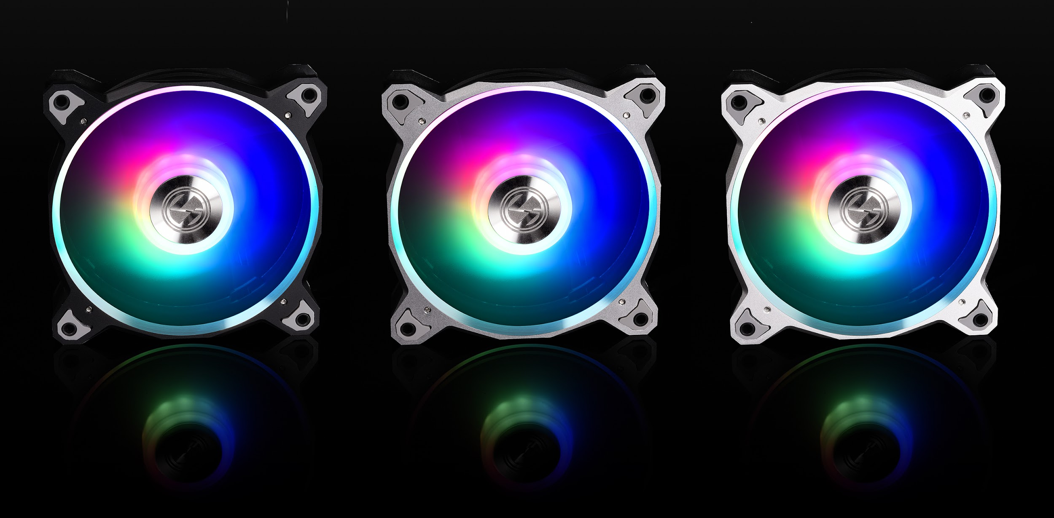

16 Lighting Modes and 9 Lighting Speed Levels via an RGB Controller
A chassis is only as good looking as how it is lit, and the BORA Digital offers all the lighting effects one could desire. Customizable via an exclusive controller, enthusiasts can switch between 16 unique lighting modes and 9 progressive lighting speed levels. Because sometimes words are not enough, here is a video to experience first hand the modes available: https://youtu.be/e2Q3p-zXJSs

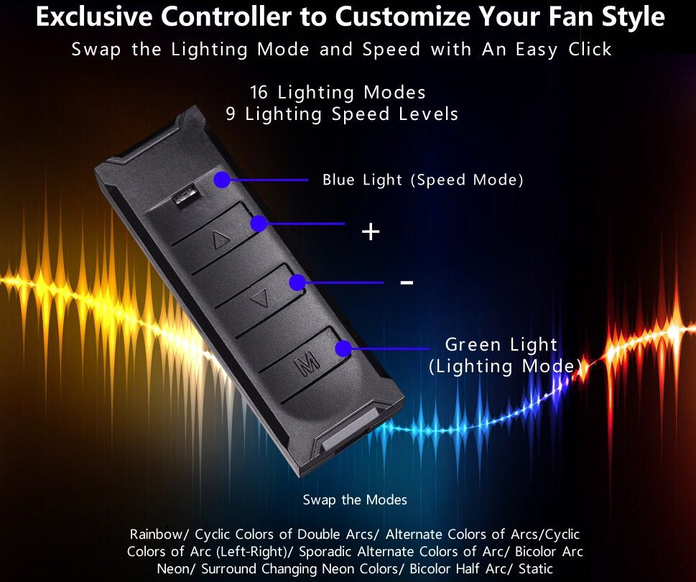

Attention to detail is everything, that is why perfectionist will be happy to know the BORA Digital is compatible with their favorite LIAN LI STRIMER 24-pin RGB cable for a synchronized and harmonious lighting effect, as well as with a wide variety of motherboards LED management software such as the ASUS AURA Sync, GIGABYTE RGB Fusion, MSI Mystic Light Sync, and ASRock Polychrome Sync.

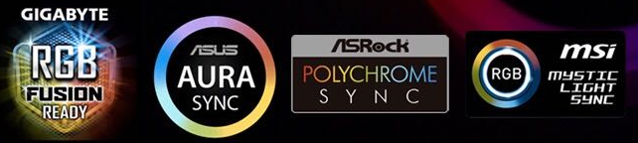

Unbeatable Silent Cooling Solution
LIAN LI made sure to design the BORA Digital to perform as quietly as possible. Firstly, rubber pads are located on all contact points to prevent unnecessary vibrations that may steer the gamer’s attention away from his intense gameplay. Secondly, the BORA Digital fan blades are mounted on fluid dynamic bearing which keeps friction to a minimum and provides a smooth spinning experience even at high revolution. Lastly, the fan speed can be adjusted as needed from as low as 900-1800 RPM with 19.4-29 dBA for the quietest experience. Make your PC comfortable to be around, keep its noise down with the BORA Digital.
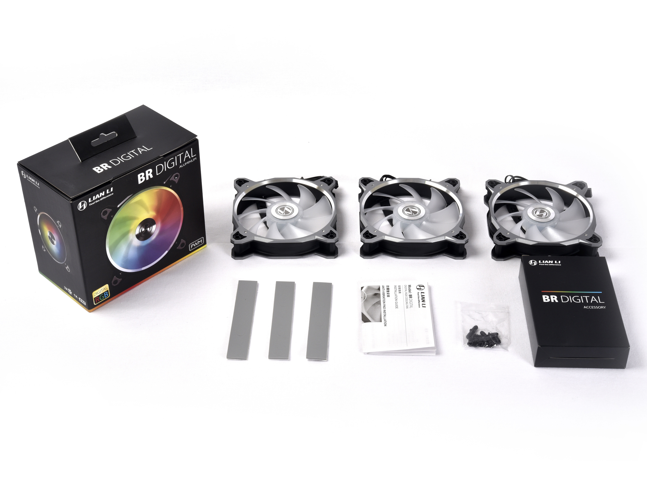
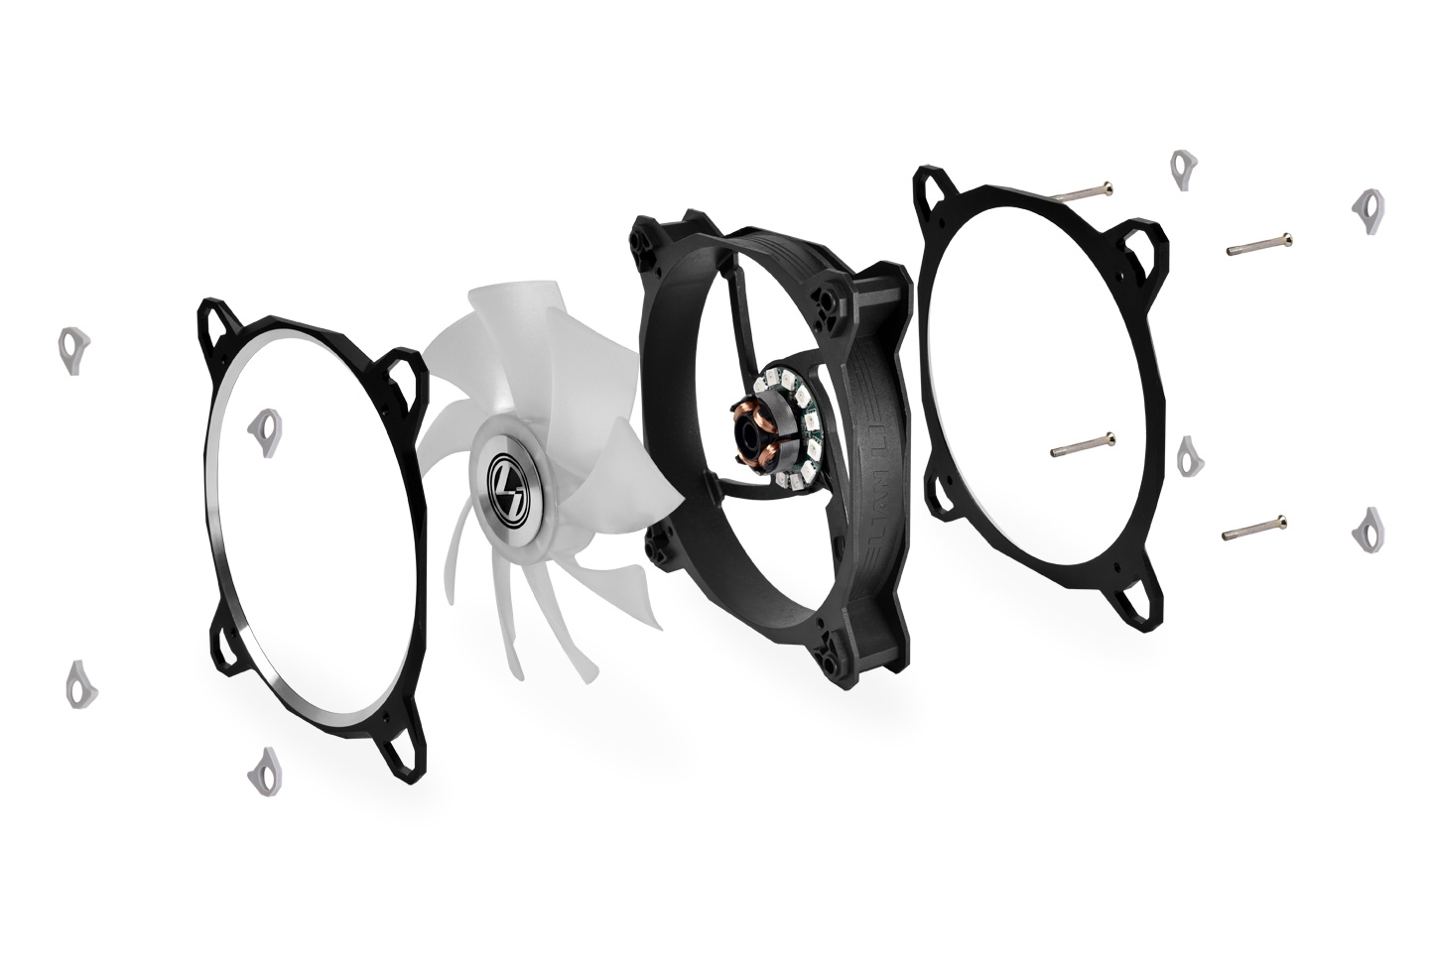

Specifications
Fan Dimension | 120mm x 120 mm x 27mm
Rated Voltage | DC 12V (LED Voltage 5V)
Fan Speed | 900 ~ 1800 RPM
Max. Air Pressure | 1.46 m-H20
Max. Air Flow | 57.97 CFM
Acoustical Noise (Min.-Max.) | 19.4 ~ 29 dBA
Insulation Type | Fluid Dynamic Bearing
Operation Voltage | 10.8V – 13.2V
Start-up Voltage | ≥ 6V (Duty Cycle 100%)
Input Current | Max. 0.45A
Input Power | Max 5.4W

The MSRP of BORA Digital is $59.99 USD, which includes a set of 3 fans, an RGB controller, power cables, daisy chaining cables as well as an LED hub. For more information of the LIAN LI BORA Digital fan, see the official product page here: http://www.lian-li.com/bora-digital/

BORA Digital video: https://www.youtube.com/watch?v=qmMY5E4Z8s8&feature=youtu.be

To get your hands on the new BORA Digital at NEWEGG:
Grey
https://www.newegg.com/Product/Product.aspx?Item=9SIAFST97M6793&ignorebbr=1
Silver
https://www.newegg.com/Product/Product.aspx?Item=9SIAFST97M6790&ignorebbr=1
Black
https://www.newegg.com/Product/Product.aspx?Item=9SIAFST97M6792&ignorebbr=1

Like and follow LIAN LI’s Facebook page to stay updated: https://www.facebook.com/LianliGlobal

About LIAN LI
LIAN LI Industrial Co. Ltd is an Aluminum Chassis and Chassis peripheral manufacturer and provider of industrial wholesale as well as OEM & ODM services for the PC industry as required. With over 20 years of service excellence, ISO 9001 certification and a team of professional staff willing to do the utmost to deliver durable, superior quality products, all backed by a 2-year warranty*; your satisfaction is guaranteed (*conditions apply). To learn more about LIAN LI, please visit their official website: http://www.lian-li.com/. You can also visit LIAN LI on Facebook or follow LIAN LI on Instagram: @LianLiHQ

